chart 1: the rate of average applying and studying kills in it every course
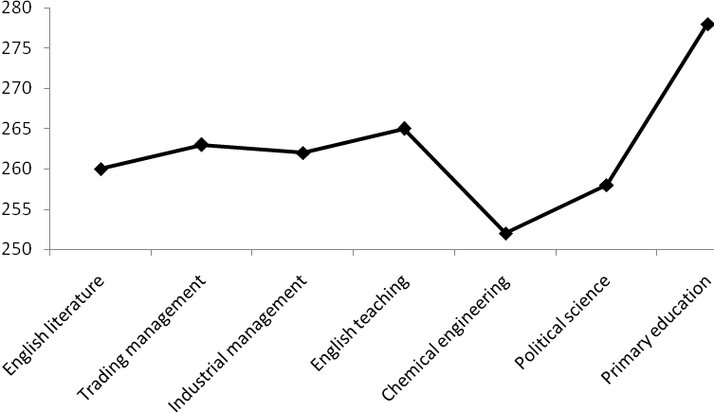

Table 1; the number of statistical society
course name |  | English literature |  | Trading management | Industrial management | English teaching | Chemical engineering | Political science | Primary education | total
number | Successful |  | 3 | 35 | 24 | 20 | 36 | 26 | 16 | 170
number | Unsuccessful |  | 3 | 35 | 24 | 20 | 36 | 26 | 16 | 170

Table 2: one-way ANOVA analyzing exam for comparing the scale of applying learning and studying skills among students of different courses
Changes sources | Square sum | Freedom degree | Square average | Mount of static | Meaningfulness level
Intergroup affect | 19198.30 | 6 | 3199.717 | 2.165 | 0.046
Intragroup affect | 492118.3 | 333 | 1477.833
Total | 511316.6 | 339

Table 3: Tukey confidence interval for chasing exams
Course one | Course two | Averages differences | Meaningfulness level | Sure distance
 |  |  |  | Down bank | Up bank
English literature | Trading management  Industrial management  Teaching English  Chemical Engineering  Political science  Primary education | -1.37  -0.88  -3.22  9.51  4.2  -17.32 | 1  1  1  0.997  1  0.951 | -47.88  -50.26  -53.14  -38.54  -44.97  -68.06 | 47.14  48.51  46.71  57.56  53.37  33.41
Trading management | Industrial management  English teaching  Chemical Engineering  Political science  Primary education | 0.49  -1.85  10.87  5.57  -15.96 | 1  1  0.560  0.986  0.452 | -20.88  -24.45  -7.21  -15.31  -40.29 | 21.86  20.75  28.96  26.44  8.38
Industrial management | English teaching  Chemical Engineering  Political science  Primary education | -2.34  10.38  5.07  -16.45 | 1  0.735  0.995  0.499 | -26.76  -9.92  -17.75  -42.47 | 22.7  30.69  27.90  9.58
And English teaching | Chemical Engineering  Political science  Primary education | 12.27  7.42  -14.11 | 0.584  0.970  0.716 | -8.87  -16.57  -14.51 | 34.32  31.40  12.94
Chemical Engineering | Political science  Primary education | -5.31  -26.83 | 0.985  0.013 | -25.09  -50.23 | 14.48  -3.43
Political science | Primary education | -12.52 | 0.166 | -47.14 | 4.10

Table 4: the rate of using learning
Course | Average
English literature  Trading management  Industrial management  English teaching  Chemical Engineering  Political science  Primary education | 261. 33  262. 70  262. 21  264. 55  251. 83  257. 13  278. 66

Table 5: T test four investigating the difference between applying studying and learning skills in unsuccessful and successful students

The amount of T static | Freedom degree | Meaningfulness level | Average |  |  | Averages difference
8.193 | 338 | 0.00 | Successful | Unsuccessful |  | 31. 571
8.193 | 338 | 0.00 | 276. 32 |  | 244. 75 | 31. 571

Tables 6: multiple correlation between every study skill and average
 | Motivation | attitude | Time management | Exciting calmness | Concentration | Date a processing | Study skills | Choosing major points | Self assessment | Examining guidelines | Average
Motivation | 1
attitude | .59 | 1
Time management | .61 | .48 | 1
Exciting calmness | .52 | .53 | .47 | 1
Concentration | .64 | .56 | .63 | .66 | 1
Date a processing | .43 | .31 | .33 | .33 | .35 | 1
Study skills | .38 | .32 | .37 | .20 | .31 | .49 | 1
Choosing major points | .50 | .48 | .31 | .55 | .48 | .50 | .37 | 1
Self assessment | .45 | .30 | .51 | .22 | .43 | .51 | .45 | .27 | 1
Examining guidelines | .53 | .48 | .46 | .56 | .58 | .42 | .39 | .50 | .33 | 1
Average | .25 | .27 | .26 | .51 | .34 | .38 | .22 | .33 | .20 | .33 | 1

Table 7: performing regression for studying the effectiveness of every study skills on students average
Model | Multiple decision | Balanced multiple decision
Motivation, attitude, time management, exciting calmness, concentration, Data Processing, studying skills, choosing major points, self assessment, examining guidelines | . 289 | . 267
Motivation, attitude, exciting calmness, concentration, Data Processing, studying skills, choosing major points, self assessment, examining guidelines | . 289 | . 270
Motivation, attitude, exciting calmness, Data Processing, studying skills, choosing major points, self assessment, examining guidelines | . 289 | . 272
Motivation, attitude, exciting calmness, Data Processing, studying skills, choosing major points,self assessment | . 289 | . 274
Motivation, attitude, exciting calmness, Data Processing, studying skills, self assessment | . 288 | . 275
Motivation, exciting calmness, Data Processing, studying skills, self assessment | . 287 | . 276
Motivation, exciting calmness, Data Processing, studying skills | . 276 | . 277
Motivation, exciting calmness, Data Processing | . 280 | . 274
exciting calmness, Data Processing | . 277 | . 272

